
COMSATS University Islamabad,
Sahiwal Campus

SOFTWARE DESIGN DESCRIPTION
(SDD DOCUMENT)

for

<MedMind>
Version 1.0

By
Sultan Mehmood CIIT/SP23-BCS-179/SWL
Umair Idrees CIIT/SP23-BCS-193 /SWL

Supervisor
Ms. Raheela Shahzadi

Bachelor of Science in Computer Science (2023-2027)

Table of Contents
1. Introduction 6
1.1. Purpose 6
1.2. Scope 6
1.3. Modules 7
1.3.1. Lab Report Analyzer Module: 7
1.3.2. Lifestyle Recommendation Module 7
1.3.3. AI Health Assistant Module 7
1.3.4. Health Blog Module 7
1.3.5. Health Trend Analysis Module 7
1.3.6. Medical Term Simplifier Module 7
2. Design methodology and software process model 7
2.1. Design Methodology 7
2.2. Software Process Model 8
3. System overview 8
3.1. General Description 8
3.2. Context 8
3.3. Design 9
4. Architectural design 9
4.1. Modular Program Structure 9
4.1.1. Presentation Layer (Frontend) 9
4.1.2. Application Logic Layer (Backend) 10
4.1.3. AI Processing Layer 10
4.1.4. Database Layer 10
4.1.5. AI Disease Detection Layer 11
5. Process flow/Representation 12
5.1. Major Process: Lab Report Analysis 12
5.1.1. Process Description 12
5.2. Major Process: AI Chatbot Assistance 13
5.2.1. Process Description 13
6. Design models 16
6.1. Class Diagram 16
6.2. Sequence Diagram 16
6.3. State Transition Diagram 17
7. Data Design 17
7.1. Database Architecture 18
7.2. Database Table Design 18
7.2.1. Table: processed_results 18
7.3 Database Workflow 19
7.4 Database Functions 19
7.4.1 Function: init_db() 19
7.4.2 Function: save_result() 20
7.4.3 Function: get_recent_results() 20
7.5 Data Storage Format 20
7.6 Future Database Enhancements 21
8. Algorithm & Implementation 21
8.1. Class: AuthRepository 21
8.1.1 Function: login(email, password) 21
8.1.3. Function: register(userData) 22
8.2. Class: ReportAnalysisService 22
8.2.1. Function: analyzeReport(file) 22
8.3. Class: Recommendation Engine 23
8.3.1 Function: generateRecommendations(userData) 23
8.4 Class: RAGHealthAssistant 23
9. Requirements Traceability Matrix (RTM) 23
10. Human Interface Design 24
10.1 Dashboard Interface 24
10.2 Report Analysis Interface 25
10.3 AI Health Assistant Interface 25
10.4 Blog Interface 25
10.5 Profile Interface 25
11. Screen Images 25
12. Screen Objects and Actions 25
13. Security Design 26
14. Performance Design 26
15. Appendix 26

Revision History

Name | Date | Reason for changes | Version

Application Evaluation History

Comments (by committee)  *include the ones given at scope time both in doc and presentation | Action Taken

Supervised by
Ms. Raheela Shahzadi

Signature

1. Introduction
MedMind is an AI-powered web-based health intelligence platform designed to help users understand medical reports and improve their lifestyle through intelligent recommendations. The system integrates Artificial Intelligence (AI), Natural Language Processing (NLP), Machine Learning, and Retrieval-Augmented Generation (RAG) techniques to provide users with simplified explanations of medical reports, personalized lifestyle guidance, and intelligent health assistance.
The platform allows users to upload lab reports in PDF, DOCX, or TXT formats. The uploaded reports are analyzed using medical knowledge bases to identify abnormalities, explain medical terms, and generate personalized health recommendations. MedMind also includes a RAG-based AI Health Assistant that answers health-related questions using trusted medical sources with citations.
The purpose of this Software Design Description (SDD) document is to provide a detailed explanation of the system architecture, software components, database structure, interfaces, design models, and implementation details of the MedMind platform. This document serves as a technical reference for developers, testers, supervisors, and stakeholders by describing how the requirements defined in the SRS will be implemented in the actual system.

1.1. Purpose
The purpose of the MedMind system is to provide users with an intelligent and user-friendly platform that simplifies complex medical information and improves health awareness. The system aims to bridge the gap between medical data and patient understanding by providing AI-generated explanations, personalized recommendations, and reliable health guidance.
The system is designed to assist users in understanding lab reports, tracking health trends, improving lifestyle habits, and accessing trusted medical information without requiring advanced medical knowledge.

1.2. Scope
The MedMind platform focuses on analyzing medical reports and providing AI-powered health assistance through a web-based system. The system allows users to upload lab reports, receive simplified explanations, generate lifestyle recommendations, interact with an AI chatbot, and access educational health blogs.
The system includes features such as:
- User authentication and profile management
- Lab report upload and analysis
- Knowledged-Based explanations
- Lifestyle recommendation
- RAG-based health chatbot
- Blog management
- Health trend visualization
- Medical term simplification
- Health summary generation
The system is designed to operate locally without paid cloud APIs and uses local AI models for analysis and recommendations. However, the platform is not intended to replace professional medical advice or emergency healthcare services.

1.3. Modules
The System will have following modules:

1.3.1. Lab Report Analyzer Module:
This module allows users to upload medical reports in PDF, DOCX, or TXT formats. The system extracts medical test values using text parsing techniques. Extracted values are compared with standard medical ranges, and abnormal values are highlighted with Knowledged-Based explanations.

1.3.2. Lifestyle Recommendation Module
This module generates personalized lifestyle recommendations based on the user’s health profile and lab report analysis. The recommendations include diet plans, exercise routines, hydration guidance, and lifestyle improvement suggestions based on WHO and AHA guidelines.

1.3.3. AI Health Assistant Module
This module provides a conversational AI chatbot using Retrieval-Augmented Generation (RAG). Users can ask health-related questions, and the system retrieves information from trusted medical sources before generating context-aware responses with citations.

1.3.4. Health Blog Module
This module provides educational health-related blogs and articles. Users can browse blogs by category, search articles using keywords, and read trusted health information related to diseases, nutrition, fitness, and wellness.

1.3.5. Health Trend Analysis Module
This module tracks user health metrics over time and visualizes trends using graphs and charts. Users can monitor changes in blood pressure, cholesterol, blood sugar, and other health indicators.

1.3.6. Medical Term Simplifier Module
This module simplifies difficult medical terminology into plain English using NLP techniques and AI-based text simplification.

2. Design methodology and software process model
The Design Methodology and Software Process Model for MedMind is given below:

2.1. Design Methodology
The MedMind system follows the Object-Oriented Programming (OOP) design methodology for the development of frontend, backend, AI modules, and database operations. The OOP methodology was selected because it supports modularity, scalability, maintainability, and reusable software components.
The MedMind system contains multiple interconnected modules such as authentication, report analysis, AI chatbot, recommendations, and blog management. OOP helps organize these functionalities into separate classes and services.
Real-world entities such as User, LabReport, Recommendation, ChatMessage, BlogPost, and HealthProfile are represented as objects with their own attributes and methods. This improves code organization and system maintainability.
The system also follows modular architecture where each module can function independently while communicating through APIs and service layers. This separation of concerns improves debugging, testing, and scalability.

2.2. Software Process Model
The MedMind system follows the Agile Software Development Process Model. Agile methodology was selected because it supports iterative development, continuous testing, flexibility, and incremental feature delivery.
The development process is divided into multiple iterations or sprints. Each sprint focuses on implementing specific modules such as authentication, report upload, AI analysis, chatbot integration, and recommendation generation.
The Agile model is highly suitable for AI-based systems because AI modules often require continuous improvement, testing, retraining, and optimization. Agile allows modifications without affecting the entire project workflow.
The Agile model also improves communication between team members, supervisors, and stakeholders through continuous feedback and evaluation sessions.

3. System overview
The detailed overview of our system is given below:

3.1. General Description
MedMind is an AI-powered health intelligence platform developed to assist users in understanding medical reports and improving health awareness. The system uses Artificial Intelligence, NLP, Machine Learning, and RAG techniques to analyze lab reports and generate health insights.
Users can upload medical reports, receive AI-generated explanations, ask health-related questions through a chatbot, and obtain personalized lifestyle recommendations. The system also provides educational health blogs and trend analysis features.
The platform uses React for frontend development, FastAPI for backend services, PostgreSQL and ChromaDB for data storage.

3.2. Context
Many users struggle to understand medical reports due to complex medical terminology and lack of healthcare knowledge. Existing health applications often provide generic information without personalization.
MedMind addresses these challenges by using AI technologies to simplify medical data, generate personalized recommendations, and provide reliable answers using trusted medical knowledge sources.
The system helps users improve health awareness while reducing dependency on expensive healthcare consultations for basic medical understanding.

3.3. Design
The MedMind system follows a Client-Server Multi-Tier Architecture.
The frontend is developed using React and Tailwind CSS. The backend uses FastAPI REST APIs and WebSocket communication for chatbot interaction.
The knowledge-based explanation layer uses ontology-driven rules, deterministic clinical mappings, regex parsing, unit normalization, confidence scoring, and structured medical reference data to generate patient-centered interpretations without relying just on generative AI models. The system includes:
- Frontend Layer
- Backend Service Layer
- Processing Layer
- Database Layer
- Vector Database Layer
The architecture supports modularity, scalability, maintainability, and local hardcoded knowledge for latency improvement without cloud APIs.

4. Architectural design
The Architectural Design of MedMind is explained below:

4.1. Modular Program Structure
The MedMind system follows Client-Server Multi-Tier Architecture combined with the MVC (Model-View-Controller) design pattern.

4.1.1. Presentation Layer (Frontend)
Role
Responsible for user interaction and UI rendering.
Components
- React Components
- Tailwind CSS UI
- Dashboard Pages
- Chatbot Interface
- Report Analysis Interface
Interaction
The frontend sends API requests to the backend and displays results to users.

4.1.2. Application Logic Layer (Backend)
Role
Handles business logic, validation, authentication, and API communication.
Components:
- FastAPI Services
- Authentication Services
- Recommendation Engine
- Report Processing Services
Interaction
Processes requests from frontend and communicates with AI modules and databases.

4.1.3. Knowledge-Based Processing Layer
Role
Processes medical laboratory data using ontology-driven NLP techniques, regex-based extraction, unit normalization, validation, confidence scoring, and rule-based patient-centered explanation generation.
Components:
- Medical Ontology & Test Registry
- Regex-Based Extraction Engine
- Unit Normalization System
- Validation & Confidence Scoring Engine
- Rule-Based Clinical Interpretation Engine
Interaction
Processes report text and user queries.

4.1.4. Database Layer
Role
The database layer stores processed medical report data, extracted test results, AI-generated summaries, and recent analysis records.
Components
- SQLite Database
- sqlite3 Python Library
Interaction
The backend system stores processed report information inside the SQLite database and retrieves recent analysis records whenever required.
Future Enhancements
Future versions of the system may integrate:
- PostgreSQL for scalable relational storage
- ChromaDB for vector embedding storage
- RAG-based semantic retrieval systems

4.1.5. Vector Database Layer
Currently, the MedMind system does not implement vector database storage. However, future versions of the system will integrate ChromaDB to support Retrieval-Augmented Generation (RAG) functionality.
The future vector database layer will:
- Store medical embeddings
- Support semantic search
- Retrieve relevant medical knowledge
- Improve AI-generated responses
- Enhance contextual understanding
The vector database will work alongside large language models to provide more accurate and medically relevant responses.

Module Relationships
The system modules communicate in the following order:
- User interacts with Frontend
- Frontend sends requests to Backend APIs
- Backend validates requests
- AI Layer processes data
- Database stores/retrieves information
- Backend returns response
- Frontend displays results

System Architecture Diagram
The following figure 4.1 illustrates the high-level architecture and communication flow of the MedMind system.
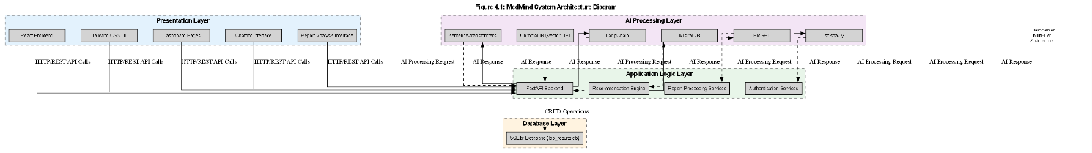
Figure 4: Architecture Diagram

5. Process flow/Representation
The process flow of MedMind with representation is given below:

5.1. Major Process: Lab Report Analysis

5.1.1. Process Description
- User uploads lab report
- System validates file
- Text extraction is performed
- NLP/Knowledge Base extracts test values
- Values are compared with normal ranges
- System generates explanations
- Recommendations are generated
- Results are stored
- Analysis is displayed
- Acitivity Diagram

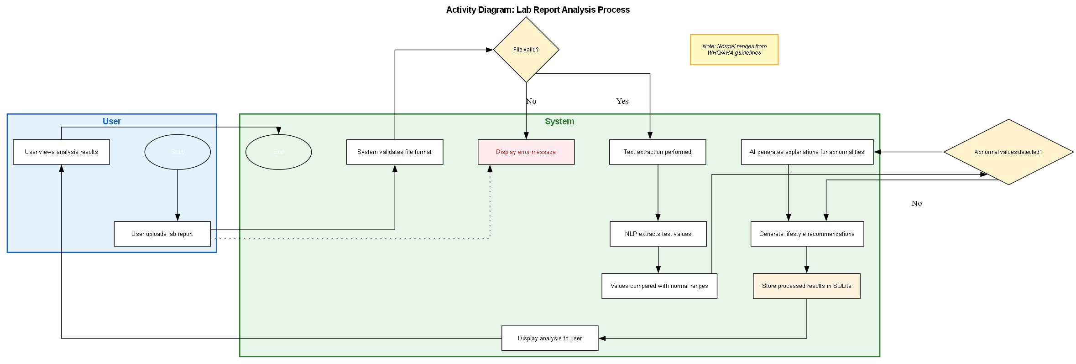
Figure 5.1: Activity Diagram 1

5.2. Major Process: AI Chatbot Assistance

5.2.1. Process Description
- User enters health question
- Query preprocessing is performed
- Embeddings are generated
- Relevant medical knowledge is retrieved from stored Kn
- Prompt is generated
- Mistral 7B generates response
- Response with citations is displayed
- Conversation is stored
- Activity Diagram

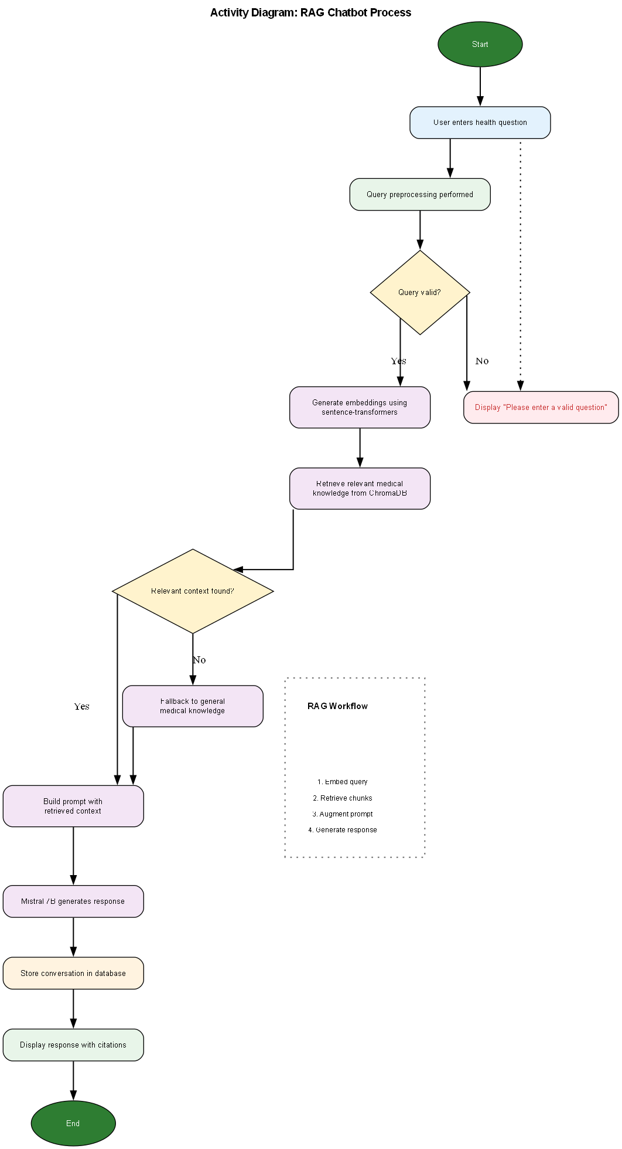
Figure 5.2: Activity Diagram 2

6. Design models
The MedMind system uses the following UML and design models:
- Class Diagram
- Sequence Diagram
- Activity Diagram
- Data Flow Diagram (DFD)
- Use Case Diagram
- Entity Relationship Diagram (ERD)

6.1. Class Diagram
The Class Diagram represents the static structure of the MedMind system by showing the major classes, attributes, methods, and relationships between different software components.
The diagram demonstrates how different modules such as medical report processing, AI analysis, NLP extraction, and database management interact with each other within the system.
The MedMind system follows an Object-Oriented Programming (OOP) architecture where each module is implemented as an independent class with specific responsibilities. This modular design improves maintainability, scalability, and code organization.
The major classes represented in the diagram include:
- User
- MedicalReport
- NLPProcessor
- AIEngine
- SQLiteDatabase
- ProcessedResult
These classes collaboratively perform report upload, AI analysis, result generation, and database storage operations.

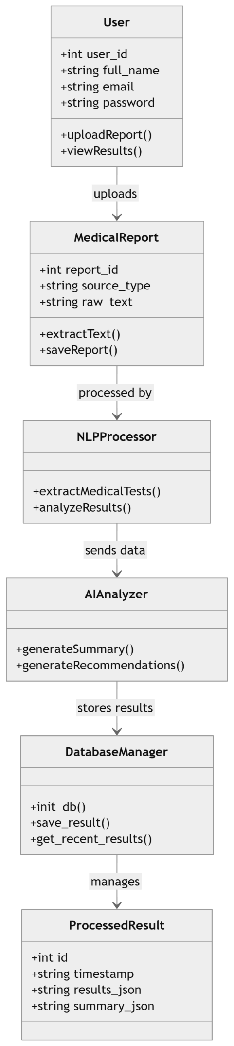
Figure 6.1: Class Diagram

6.2. Sequence Diagram
The Sequence Diagram illustrates the interaction between different components of the MedMind system during medical report analysis.
The diagram shows the chronological order of communication between:
- User
- Frontend Interface
- Backend API
- NLP Processing Engine
- AI Analysis Module
- SQLite Database
The sequence begins when the user uploads a medical report. The backend extracts report text using NLP techniques, processes medical values, generates AI-based explanations, and stores the processed results in the database before returning the final analysis to the user interface.
This diagram helps visualize runtime communication and request-response flow between system modules

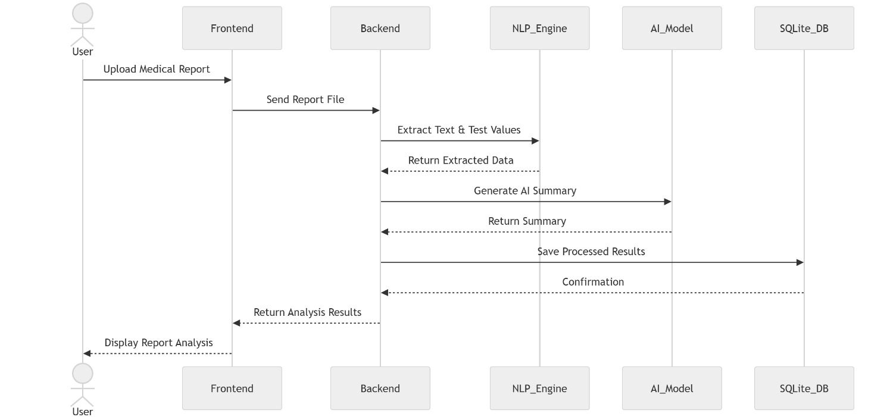
Figure 6.1: Sequence Diagram

6.3. State Transition Diagram
The State Transition Diagram represents the dynamic behavior of the MedMind system during medical report processing.
The system transitions through multiple states depending on user actions and AI processing operations.
The major states include:
- Idle State
- Report Upload State
- Validation State
- Text Extraction State
- AI Processing State
- Analysis Generation State
- Result Display State
- Database Storage State
- Error State
The diagram helps visualize how the system changes from one operational state to another during report analysis and recommendation generation
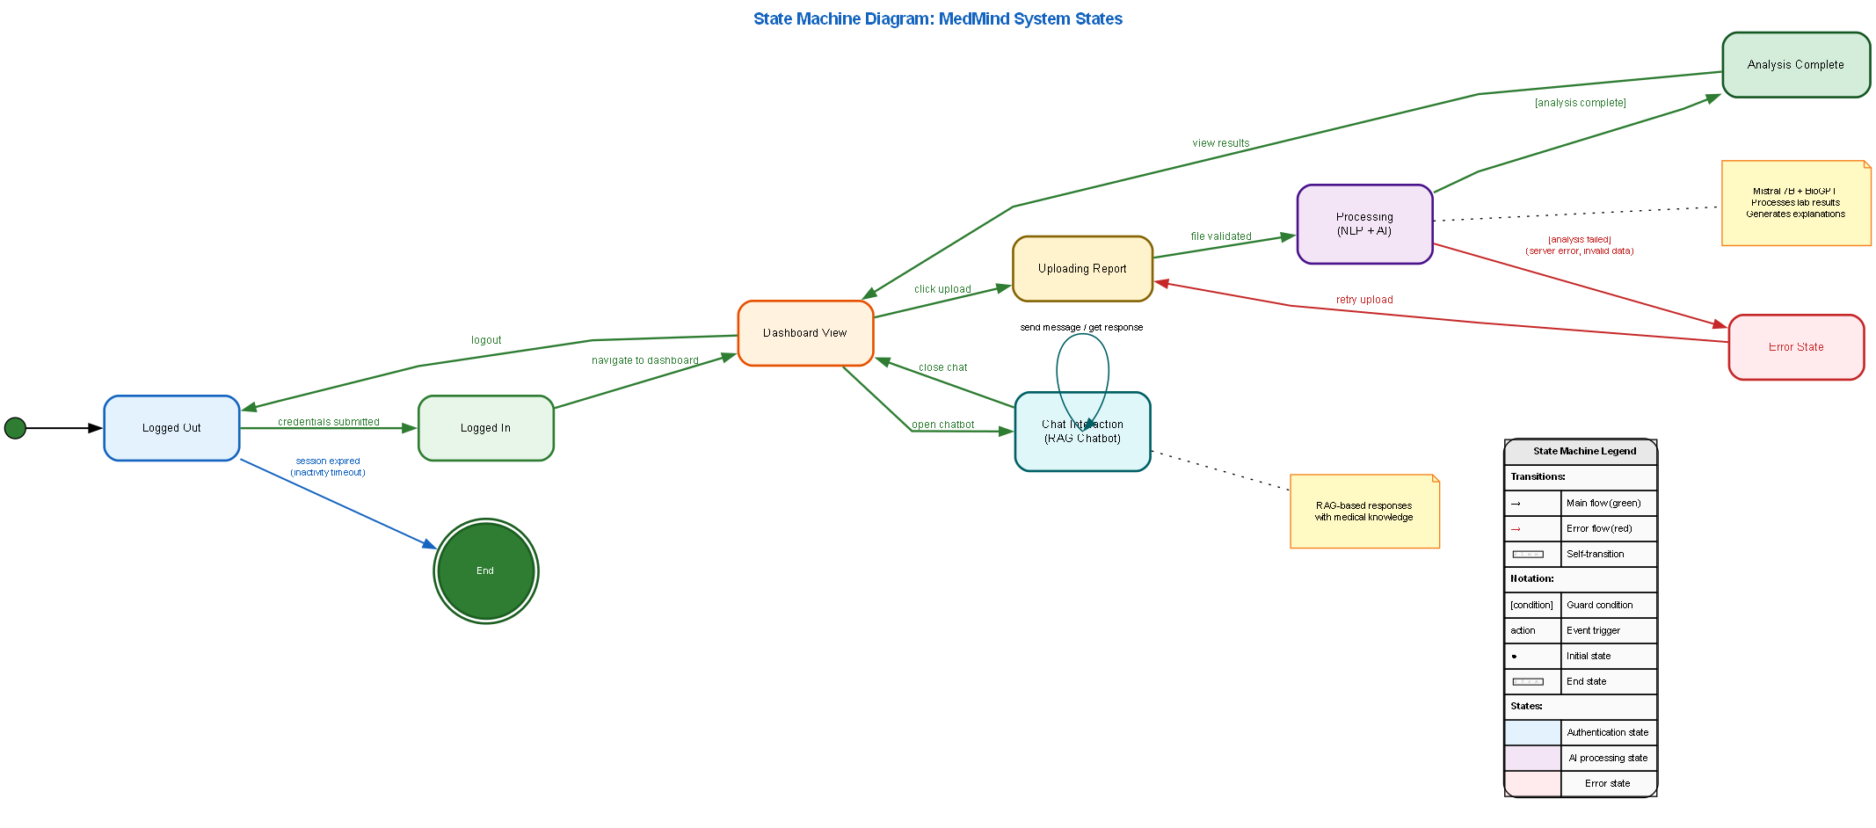

Figure 6.2: State Transition Diagram

6.4. Entity Relationship Diagram
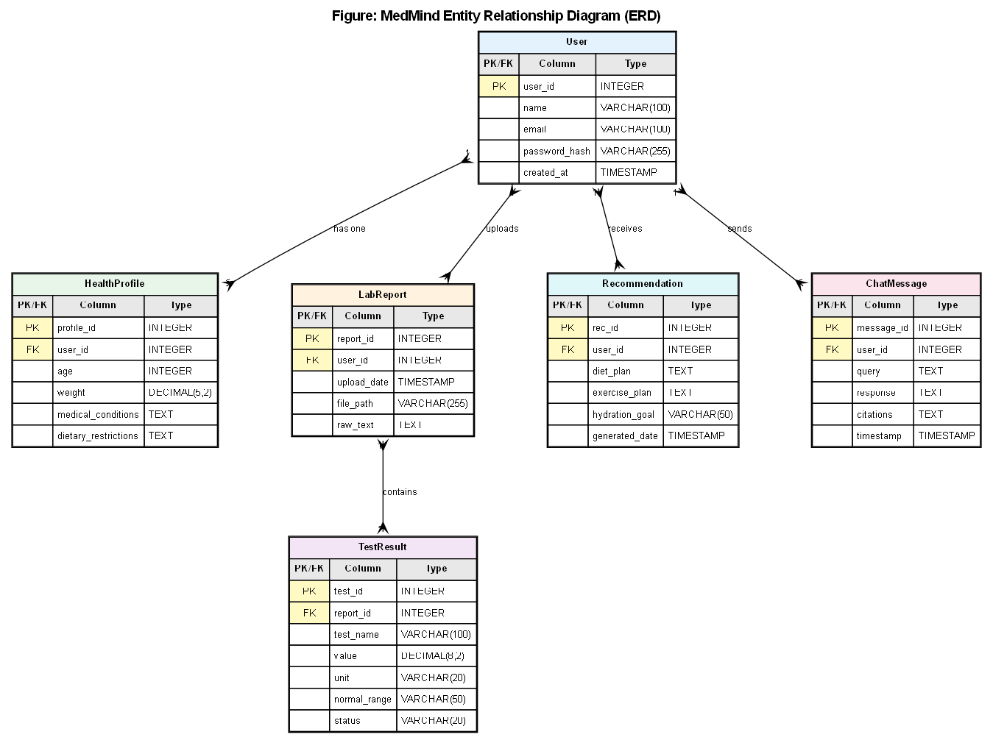
Figure 6.4: Entity Relationship Diagram

6.5. DFD
The Data Flow Diagram (DFD) represents the movement of data within the MedMind system. It illustrates how data moves between users, processing modules, AI engines, and the database system.
The DFD helps visualize:
- Data input
- Data processing
- Data storage
- Data output
- Interaction between system components
The MedMind system uses multiple DFD levels to represent increasing levels of detail.

6.5.1. Level 0 diagram
The DFD Level 0 provides a high-level overview of the MedMind system and its interaction with external entities.
External Entities
- User
- AI Processing Engine
Main Process
- MedMind System
Data Store
- SQLite Database

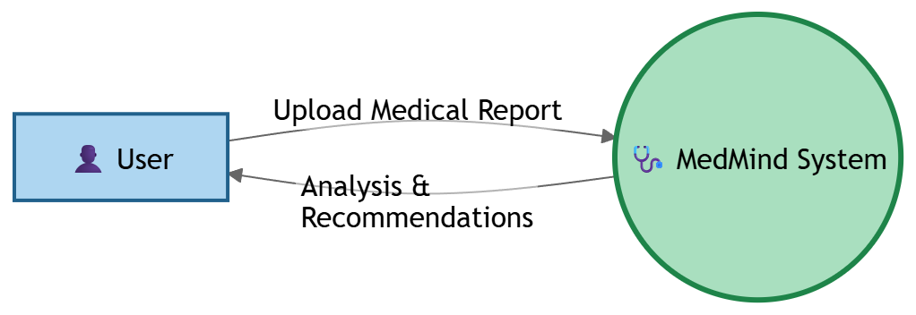
Figure 6.5.1: Level 1 DFD

6.5.2. Level 1 diagram
DFD Level 1 decomposes the MedMind system into major functional processes.
Main Processes
- Report Upload Process
- Text Extraction Process
- Medical Analysis Process
- AI Summary Generation Process
- Result Storage Process
- Result Visualization Process

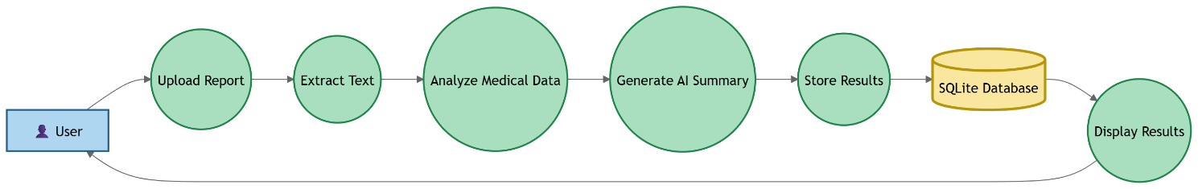
Figure 6.5.2: Level 2 DFD

6.5.3. Level 2 diagram
DFD Level 2 provides detailed decomposition of the Medical Report Analysis Process.
Process Description
I. Report Upload
The user uploads a medical report in PDF, DOCX, or TXT format.
II. File Validation
The system validates the uploaded file format and content.
III. Text Extraction
The NLP engine extracts medical text and test values from the uploaded report.
IV. Medical Data Analysis
The extracted values are compared with standard medical ranges.
V. AI Explanation Generation
The AI engine generates simplified explanations and recommendations.
VI. Database Storage
Processed results and generated summaries are stored inside the SQLite database.
VII. Result Display
The final analysis results are displayed to the user interface.

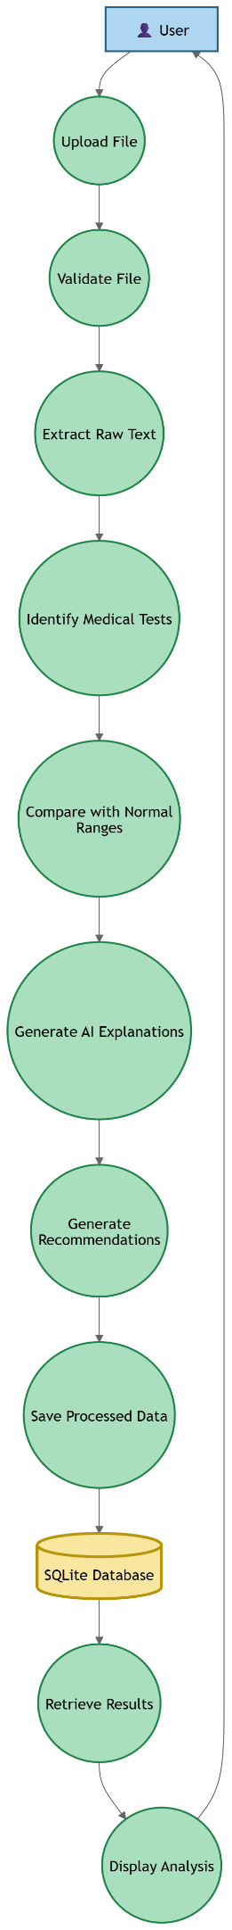
Figure 6.5.3: Level 2 DFD

7. Data Design
The MedMind system currently uses SQLite as the primary database for storing processed medical report results and AI-generated summaries. SQLite was selected because it is lightweight, easy to integrate, requires minimal configuration, and is highly suitable for local AI-based applications during the initial development phase of the project.
The database is responsible for storing:
- Processed medical report data
- Extracted medical test results
- AI-generated summaries
- Source information
- Timestamp records
The current implementation focuses on efficient local execution while maintaining flexibility for future scalability. The system stores extracted results and summaries in JSON format to support dynamic and varying medical report structures.
The database operations are implemented using Python’s built-in sqlite3 library through a dedicated database module named sqlite.py.

7.1. Database Architecture

The MedMind system follows a simple local database architecture using SQLite.
The database file used in the system is:
lab_results.db
The database module performs the following operations:
- Database initialization
- Table creation
- Result storage
- Retrieval of recent processed reports
- Database connection handling
The database architecture is designed to support:
- Fast local access
- Lightweight execution
- Easy maintenance
- Structured storage of processed medical data
Future versions of the system may migrate to advanced databases such as PostgreSQL and vector databases for Retrieval-Augmented Generation (RAG) support.

7.2. Database Table Design
Currently, the MedMind system contains one primary table named:
processed_results
This table stores processed medical report analysis results and generated summaries.

7.2.1. Table: processed_results

Field Name | Data Type | Description
id | INTEGER | Primary key for each processed record
timestamp | TEXT | Date and time when processing was completed
source_type | TEXT | Type of uploaded source (PDF, Image, or Text)
raw_text | TEXT | Extracted raw text from the medical report
results_json | TEXT | Extracted medical test results stored in JSON format
summary_json | TEXT | AI-generated summary stored in JSON format

Table 7.2: processed_results

7.3 Database Workflow
The database workflow in MedMind follows the following sequence:
- User uploads a medical report.
- The system extracts text from the uploaded file.
- NLP processing extracts medical test values.
- AI generates summaries and explanations.
- Processed results are converted into JSON format.
- The system stores all processed information inside the SQLite database.
- Recent reports can later be retrieved for display and analysis.
This workflow ensures organized storage and efficient retrieval of processed health information.

7.4 Database Functions
The database operations are implemented inside the sqlite.py module.
The major functions are described below.

7.4.1 Function: init_db()
Purpose
Initializes the SQLite database and creates the required table if it does not already exist.
Main Operations
- Connects to SQLite database
- Creates the processed_results table
- Commits changes
- Closes database connection
SQL Operation

CREATE TABLE IF NOT EXISTS processed_results (
id INTEGER PRIMARY KEY AUTOINCREMENT,
timestamp TEXT,
source_type TEXT,
raw_text TEXT,
results_json TEXT,
summary_json TEXT
)

7.4.2 Function: save_result()
Purpose:
Stores processed medical report results into the database
Parameters
Parameter | Description
source_type | Type of uploaded source
raw_text | Extracted report text
tests | Extracted medical test results
summary | AI-generated summary
Table 7.4.2: save_result
Main Operations
- Converts results into JSON format
- Inserts processed data into database
- Saves timestamps
- Commits transaction

7.4.3 Function: get_recent_results()
Purpose
Retrieves recently processed medical report summaries from the database.
Parameter
Parameter | Description
limit | Number of recent records to retrieve
Table 7.4.3: get_recent_results
Main Operations
- Fetches recent processed records
- Sorts results by latest entries
- Returns summary information

7.5 Data Storage Format
The MedMind system stores extracted medical results and summaries in JSON format inside the database.
The JSON-based storage provides:
- Flexible data representation
- Easy serialization
- Dynamic handling of different report structures
- Simplified AI result storage
Example stored structure:
{
"test_name": "Hemoglobin",
"value": 13.5,
"unit": "g/dL",
"status": "Normal"
}

7.6 Future Database Enhancements
Future versions of MedMind may include additional database tables such as:
- Users
- Authentication Records
- Health Profiles
- Chat History
- Recommendations
- Blog Management
- Analytics
The system may also migrate to PostgreSQL and vector databases such as ChromaDB to support advanced AI retrieval and scalability features.

8. Algorithm & Implementation
This section provides an overview of the major algorithms implemented in the MedMind system. Since MedMind follows Object-Oriented Design methodology, algorithms are represented as functions of classes using pseudo code and procedural descriptions.
The algorithms mainly focus on:
- User Authentication
- Lab Report Processing
- NLP-based Test Extraction
- AI Explanation Generation
- Lifestyle Recommendation Generation
- RAG-based Question Answering

8.1. Class: AuthRepository
The AuthRepository class handles authentication operations including registration, login, logout, and session management.

8.1.1 Function: login(email, password)
FUNCTION login(email, password)

QUERY user FROM users WHERE email = email

IF user NOT FOUND THEN
THROW Exception("Invalid Email")
END IF

IF password != HASH(user.password) THEN
THROW Exception("Invalid Password")
END IF

token = JWT.generate(user.id)

STORE token in session

RETURN token

END FUNCTION

8.1.3. Function: register(userData)
FUNCTION register(userData)

CHECK existing email

IF email EXISTS THEN
THROW Exception("Email already exists")
END IF

encryptedPassword = HASH(userData.password)

INSERT new user INTO database

token = JWT.generate(user.id)

RETURN token

END FUNCTION

8.2. Class: ReportAnalysisService
This class handles lab report processing and NLP analysis.

8.2.1. Function: analyzeReport(file)
FUNCTION analyzeReport(file)

VALIDATE file type

EXTRACT text from file

APPLY NLP extraction

IDENTIFY medical tests

COMPARE with normal ranges

GENERATE explanations

STORE results

RETURN analysis

END FUNCTION

8.3. Class: Recommendation Engine
Generates personalized recommendations.

8.3.1 Function: generateRecommendations(userData)
FUNCTION generateRecommendations(userData)

ANALYZE health profile

ANALYZE lab report status

MATCH WHO guidelines

MATCH AHA guidelines

GENERATE diet plan

GENERATE exercise plan

RETURN recommendations

END FUNCTION

8.4 Class: RAGHealthAssistant
Future versions of MedMind will implement Retrieval-Augmented Generation (RAG) using ChromaDB and semantic embeddings.
The future workflow will include:
- Embedding generation
- Vector similarity search
- Context retrieval
- Prompt augmentation
- AI response generation
This enhancement will improve contextual medical understanding and response quality.

9. Requirements Traceability Matrix (RTM)
The Requirements Traceability Matrix (RTM) is used to ensure that all functional requirements defined in the SRS are properly mapped to design components, implementation modules, and testing activities. It helps verify that every system requirement is addressed during development.
Requirement ID | Requirement Description | Design Component | Implementation Module | Testing Method
FR-01 | User uploads medical reports | Upload Interface | File Upload Module | Upload Testing
FR-02 | System extracts text from reports | NLP Processing Layer | OCR/Text Extraction Module | Extraction Accuracy Testing
FR-03 | System identifies medical test values | Analysis Engine | Test Extraction Module | Functional Testing
FR-04 | System compares results with normal ranges | Rule-Based Analyzer | Result Classification Module | Validation Testing
FR-05 | System generates AI explanations | AI Processing Layer | AI Summary Generator | Output Testing
FR-06 | System stores processed results | Database Layer | SQLite Database Module | Database Testing
FR-07 | System retrieves recent reports | Database Retrieval Layer | get_recent_results() Function | Retrieval Testing
FR-08 | System displays processed results | Frontend Dashboard | Result Visualization Module | UI Testing
FR-09 | System supports JSON-based storage | Data Storage Layer | JSON Serialization Module | Data Integrity Testing
FR-10 | Future support for AI chatbot | Future AI Assistant Layer | RAG + ChromaDB Module | Future Enhancement
FR-11 | Future semantic medical retrieval | Future Vector Database Layer | ChromaDB Retrieval Engine | Future Enhancement
Table 9: RTM

10. Human Interface Design
The MedMind user interface is designed using responsive web design principles to provide accessibility, usability, and simplicity for users with limited technical knowledge.
The interface is developed using:
- React.js
- Tailwind CSS
- Responsive Layout Design
The system uses:
- Sidebar navigation
- Dashboard cards
- Chat-based interaction
- Interactive tables
- Graph visualization
- Health status indicators

10.1 Dashboard Interface
The dashboard displays:
- Health summary cards
- Recent reports
- Quick access buttons
- Recommendation overview
- AI Assistant shortcut

10.2 Report Analysis Interface
Displays:
- Test values
- Status indicators
- AI explanations
- Highlighted abnormalities
- Recommendation button

10.3 AI Health Assistant Interface
Provides:
- Chat-based UI
- Streaming responses
- Source citations
- Conversation history

10.4 Profile Interface
Allows:
- Health profile editing
- Medical condition updates
- Dietary restrictions
- Activity level settings

11. Screen Images
This section contains the graphical user interface designs and screenshots of the MedMind system. These screens demonstrate how users interact with the application for report analysis, health monitoring, and AI-assisted recommendations.

11.1 Login Screen
The Login Screen allows users to securely access the MedMind platform using their registered credentials.
The interface provides:
- Email input field
- Password input field
- Login button
- Validation messages
The screen ensures authenticated access to medical report analysis and personalized recommendations.

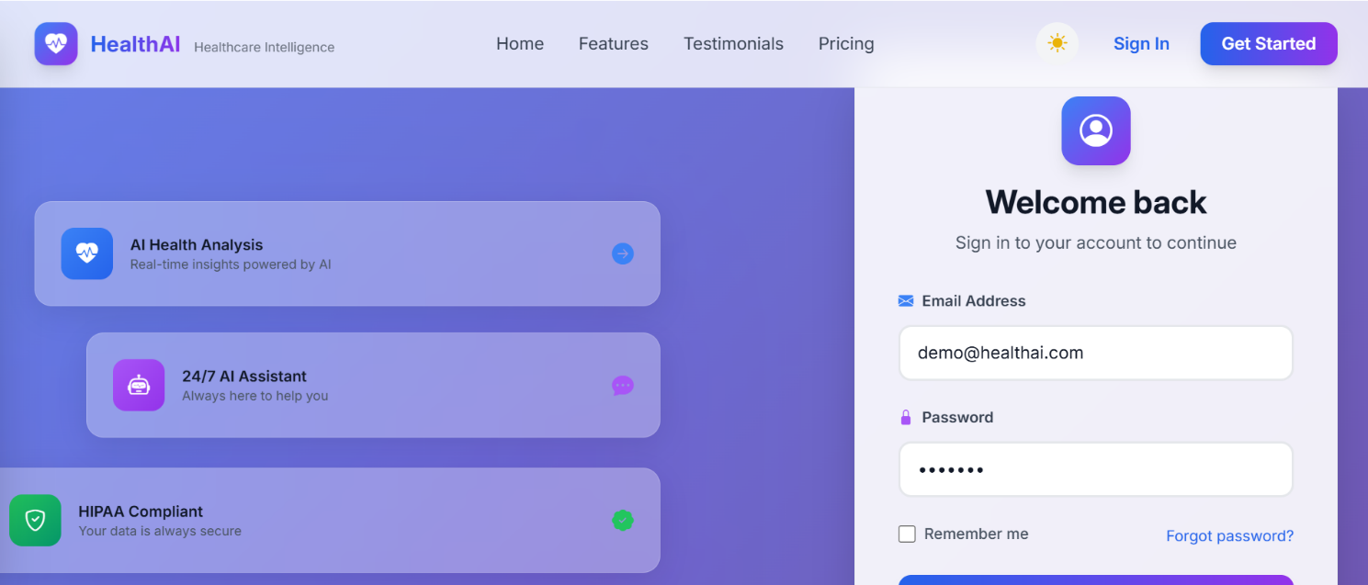
Figure 11.1: Login Screen

11.2 Dashboard Screen
The Dashboard Screen serves as the main interface of the MedMind platform.
It provides quick access to:
- Recent reports
- Health summaries
- Upload options
- Recommendation shortcuts
- AI Assistant navigation
The dashboard presents health-related information using cards, charts, and summary sections for improved user experience.
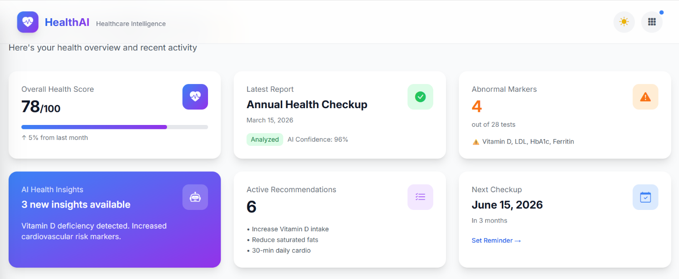
Figure 11.2: Dashboard Screen

11.3 Health Profile Screen
The Health Profile Screen allows users to manage and update their personal health information.
Users can configure:
- Age
- Weight
- Height
- Activity level
- Medical conditions
- Dietary restrictions
This information is used for generating personalized recommendations.

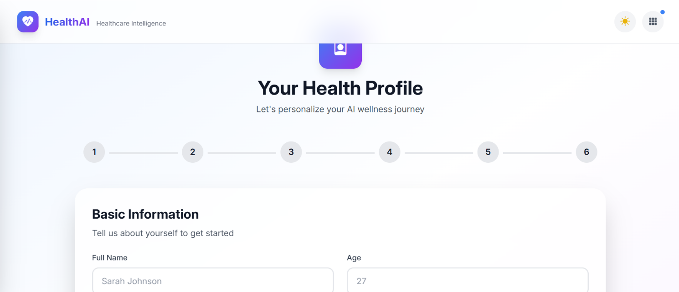
Figure 11.3: Health Profile Screen

11.4 Report Upload Screen
The Report Upload Screen allows users to upload medical reports for AI analysis.
Supported formats include:
- PDF
- DOCX
- TXT
The uploaded reports are processed using NLP and AI techniques to extract medical information and generate explanations.
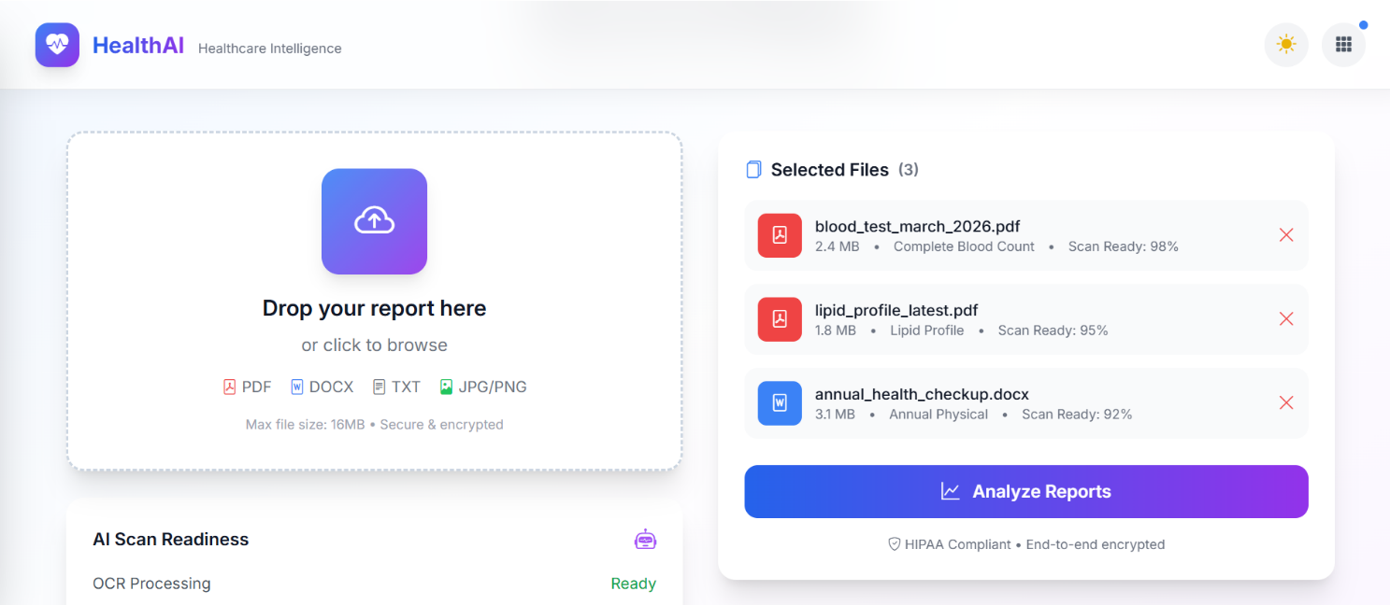

Figure 11.4: Report Upload Screen

11.5 Report History Screen
The Report History Screen displays previously analyzed medical reports and generated summaries.
Users can:
- View recent reports
- Access previous analysis
- Track historical results
- Review generated recommendations
This module improves accessibility and long-term health tracking.

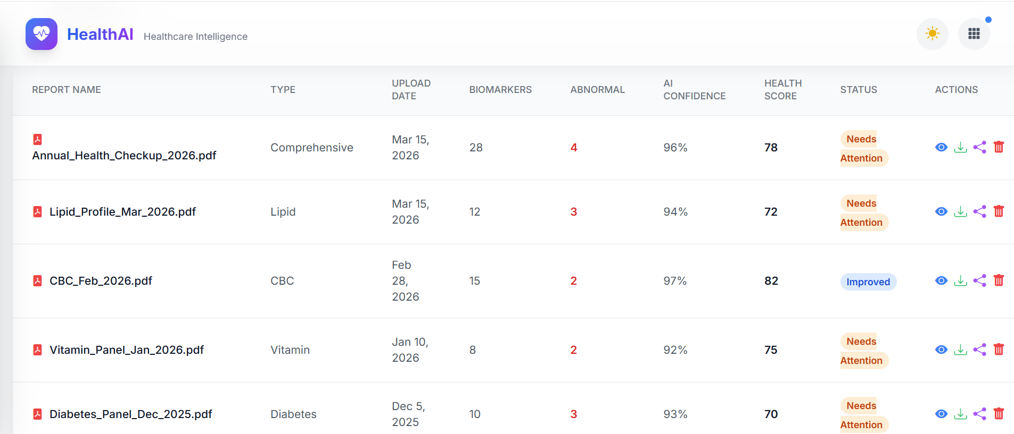
Figure 11.5: Report History Screen

12. Screen Objects and Actions
Screen | Object | Action
Login Page | Login Button | Authenticate User
Register Page | Register Button | Create New Account
Dashboard | Upload Button | Upload Report
Analysis Page | Analyze Button | Start Analysis
Chatbot Page | Send Button | Send Query
Blog Page | Search Bar | Search Articles
Profile Page | Save Button | Save Health Data
Table 12: Screen Objects and Actions

13. Security Design
The current MedMind implementation focuses on secure local processing of medical reports and protected database operations.
Security measures include:
- Input validation
- Controlled file handling
- Secure SQLite operations
- JSON serialization validation
Future versions of the system will implement:
- JWT Authentication
- Role-Based Access Control
- Secure user accounts
- Encrypted session handling

14. Performance Design
The system is optimized for local execution on standard laptops.
Performance strategies include:
- Quantized AI models
- Cached responses
- Efficient database indexing
- Streaming AI responses
- Optimized NLP pipelines
The system supports up to 10 concurrent users on 16GB RAM systems.

15. Appendix

[1] | A. H. Association, "Lifestyle and Cholesterol Guidelines," 2021. [Online]. Available: https://www.heart.org.
[2] | W. H. Organization, "Healthy Diet," 2020. [Online]. Available: https://www.who.int/news-room/fact-sheets/detail/healthy-diet.
[3] | T. Brown, B. Mann, N. Ryder, M. Subbiah, J. Kaplan, P. Dhariwal, A. Neelakantan, P. Shyam, G. Sastry, A. Askell, S. Agarwal, A. Herbert-Voss, G. Krueger, T. Henighan, R. Child and Rames, "Language models are few-shot learners," in Advances in Neural Information Processing Systems, 2020.
[4] | LangChain, "LangChain Documentation," 2024. [Online]. Available: https://docs.langchain.com.
[5] | M. Research, "BioGPT: Generative pre-trained transformer for biomedical text generation and mining," 2022. [Online]. Available: https://github.com/microsoft/BioGPT.
[6] | Chroma, "Chroma Vector Database Documentation," 2024. [Online]. Available: https://www.trychroma.com.
[7] | Ollama, "Ollama: Get up and running with large language models locally," 2024. [Online]. Available: https://ollama.com.
[8] | R. Institute, "LOINC: Logical Observation Identifiers Names and Codes," 2024. [Online]. Available: https://loinc.org.

